
BASEBALL/SOFTBALL SCHOLARSHIP REQUEST

Name of Player________________________________________________________________

Parent/Guardian Name ________________________________________________________

Address ____________________________________________________________________

City _______________________________________ State ____________ Zip ____________

Home Phone _______________________________ Cell Phone________________________

Grade ______________________School Attending _________________________

Team/Coaches Name (if known)_________________________________________________

Amount of Scholarship Requested: 25%____ 50%____ 75%____ 100%_____
(percentage of appropriate individual fee)

Amount of Fee Able to Pay $__________

Reason for Request (please explain in detail)

_____________________________________________________________________

_____________________________________________________________________

_____________________________________________________________________

____________________________________ _________________________
Parent/Guardian Signature Date

Please email back to program you are requesting a scholarship for.
Baseball: ejrtdirectorbb@gmail.com
Softball: ejrtsoftball@gmail.com

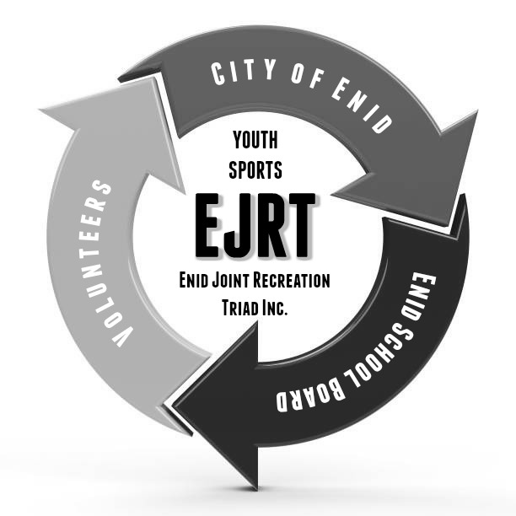
EJRT OFFICE USE ONLY

Approved __________________ Not Approved __________________

EJRT Officer ______________________________

